**RAVE KT SESSION 2**

* This entire session is all about the RAVE to RECON configuration

1. The place to find the configuration:

The configuration lies in the “AVAdmin” study in the home page within which each study is specified as a single subject and within that subject there will be a folder named RECON. This folder carries the configuration mapping regarding the fields for which the data will be going from RAVE to RECON.

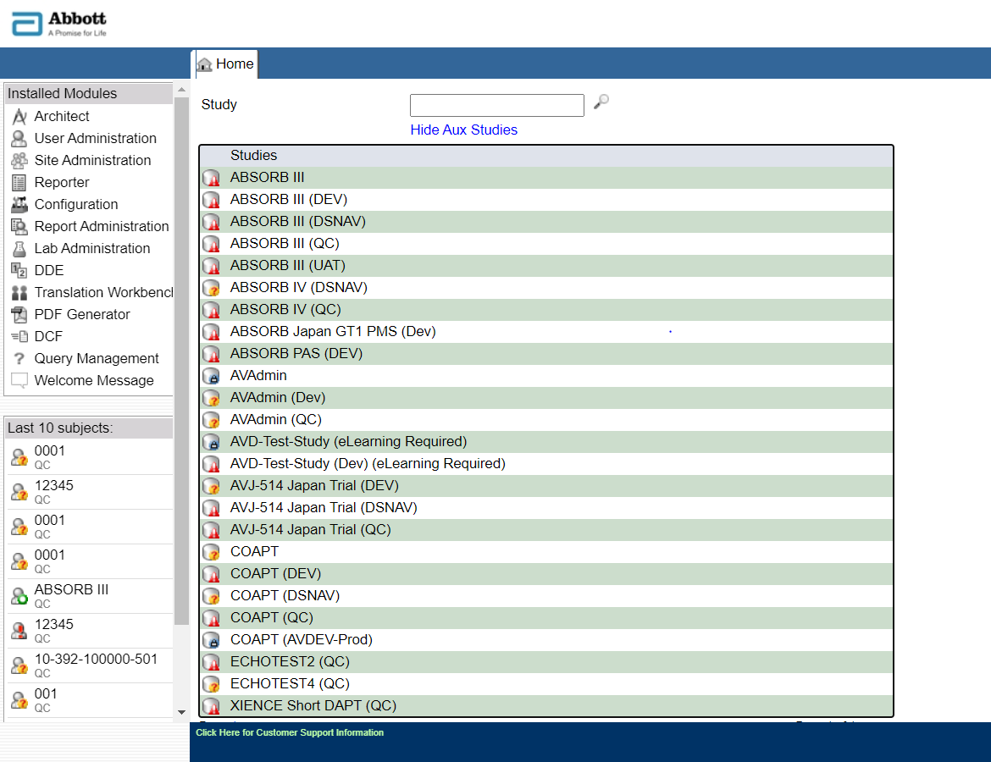

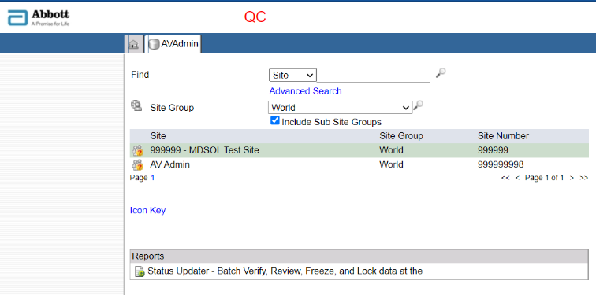

Figure 2 The AVADmin SIte

AVADmin study

Figure 1 AVAdmin in home page

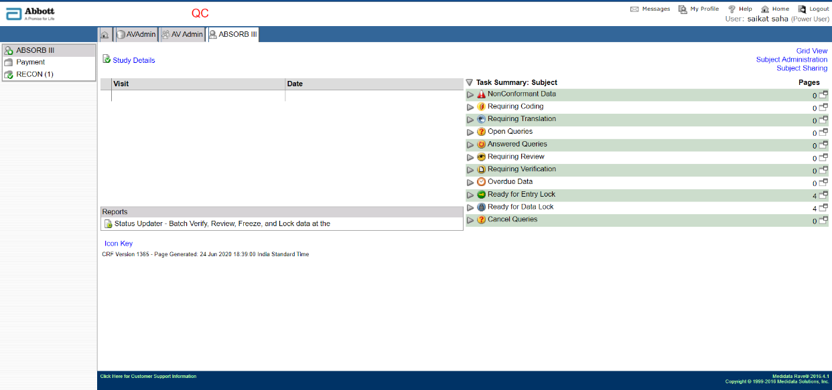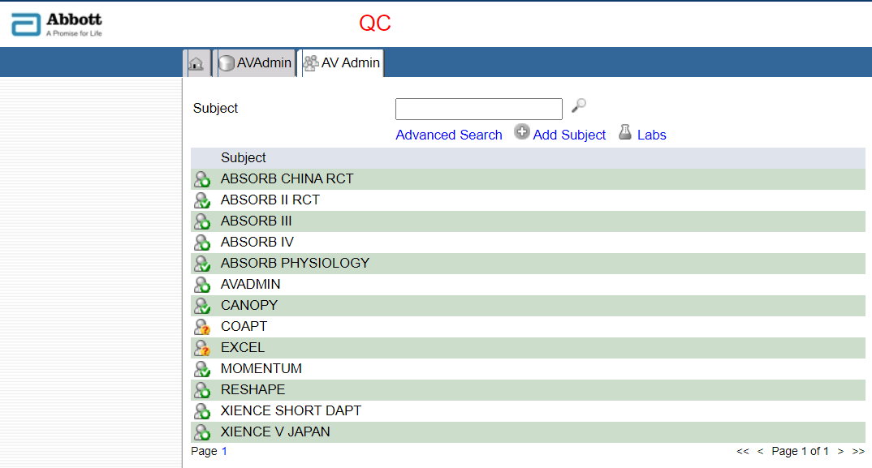

Figure RECON configuration folder

Figure 3 AvAdmin Subject page

The presence of this folder depicts there’s an existing connection between RAVE and RECON for this study

Select any of the study created as the subjects

1. Metadata:

There are 3 types Metadata are available in Rave that are configured to flow into the Recon.

1. AE Metadata
2. DM Metadata
3. Subject Enrollment Metadata

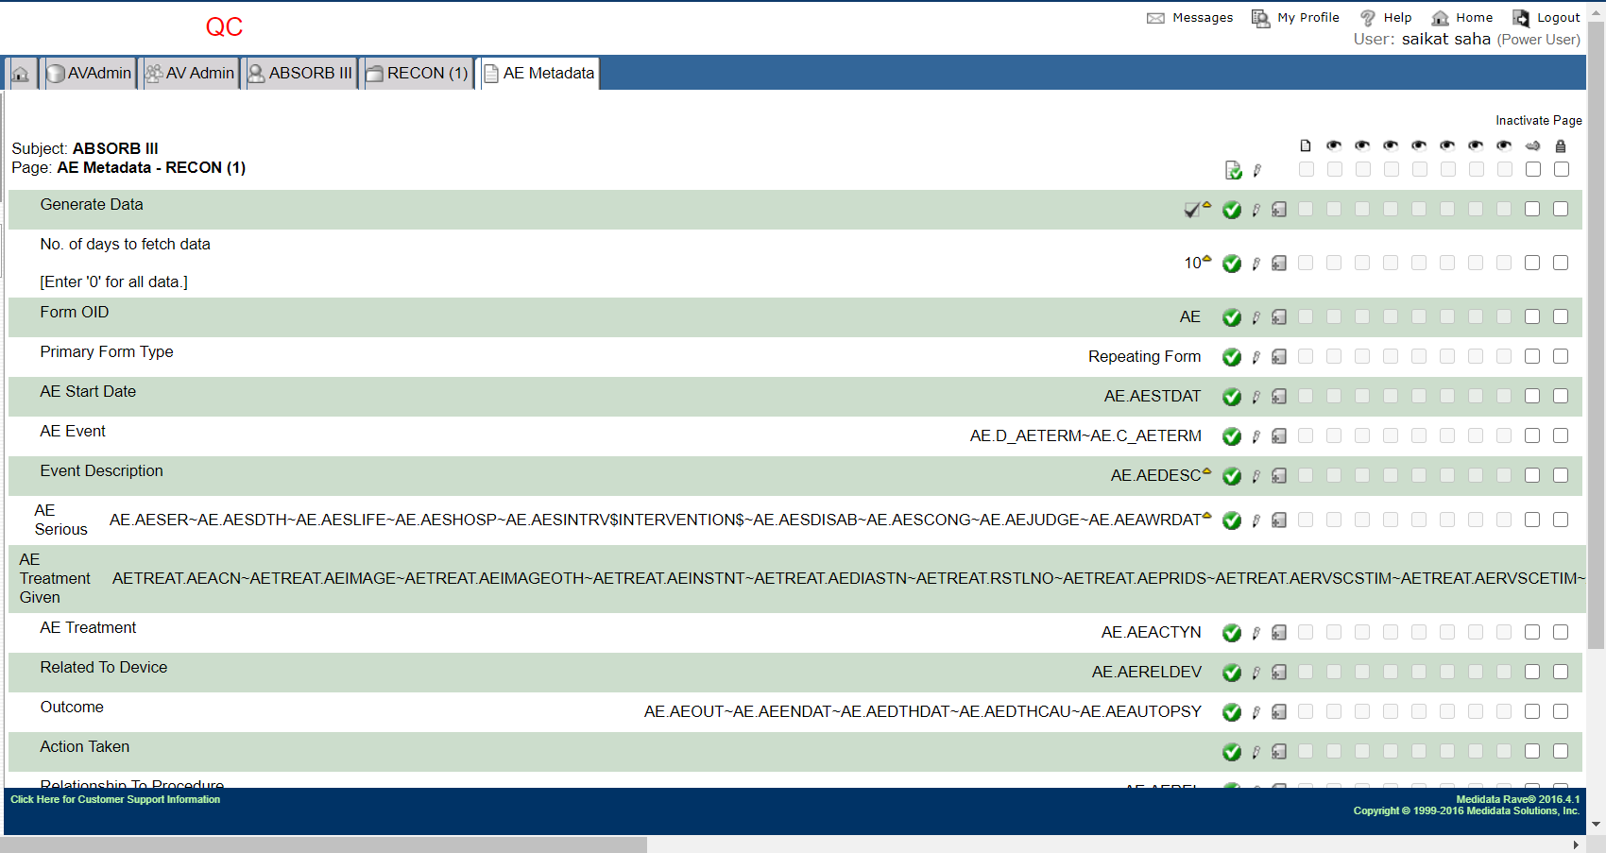

Figure AE Metadata

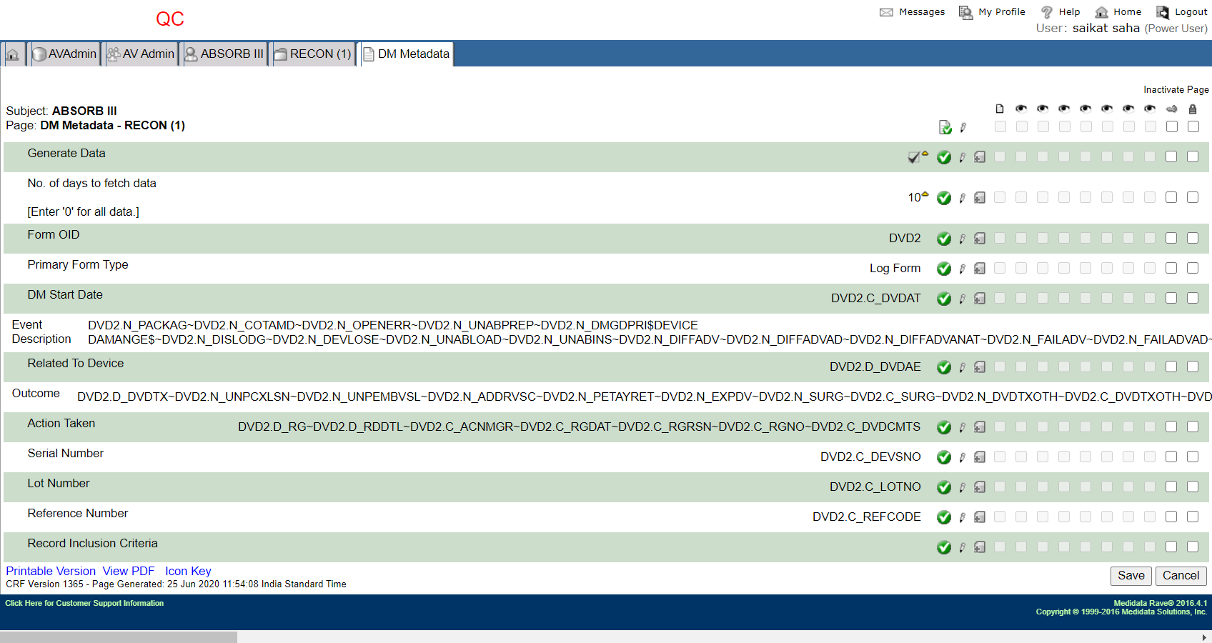

Figure DM Metadata

s

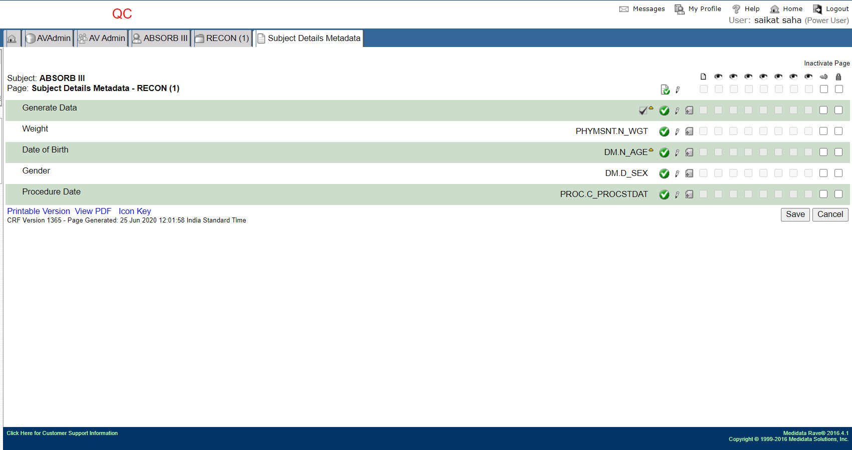

Figure Subject Details Metadata

1. List of fields in the subject view to understand the relation:

Below are the list of fields that are available in Subject level which are configured in RECON details.

1. AE Metadata and AE Form and AETREAT Form relation =>













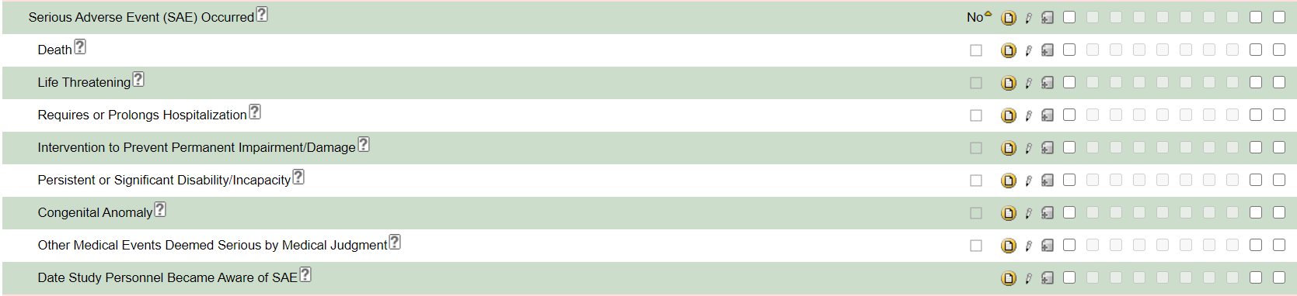



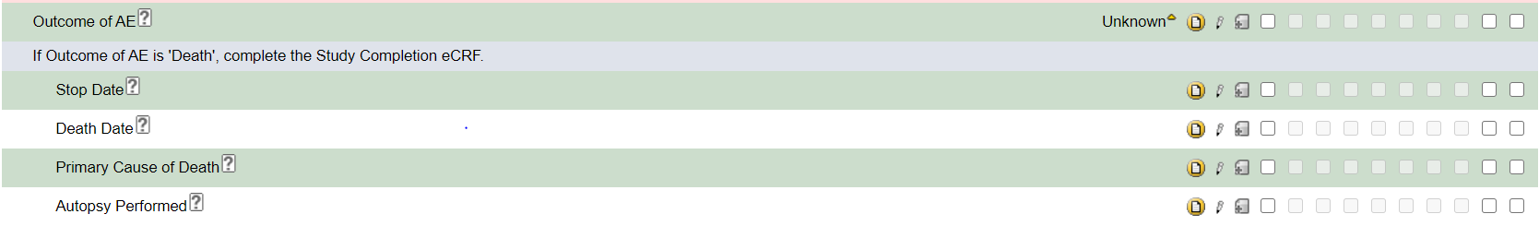







Figure AE Form and AETREAT Form fields’ data that will be going to RECON

1. DM Metadata from Device Deficiency Form:





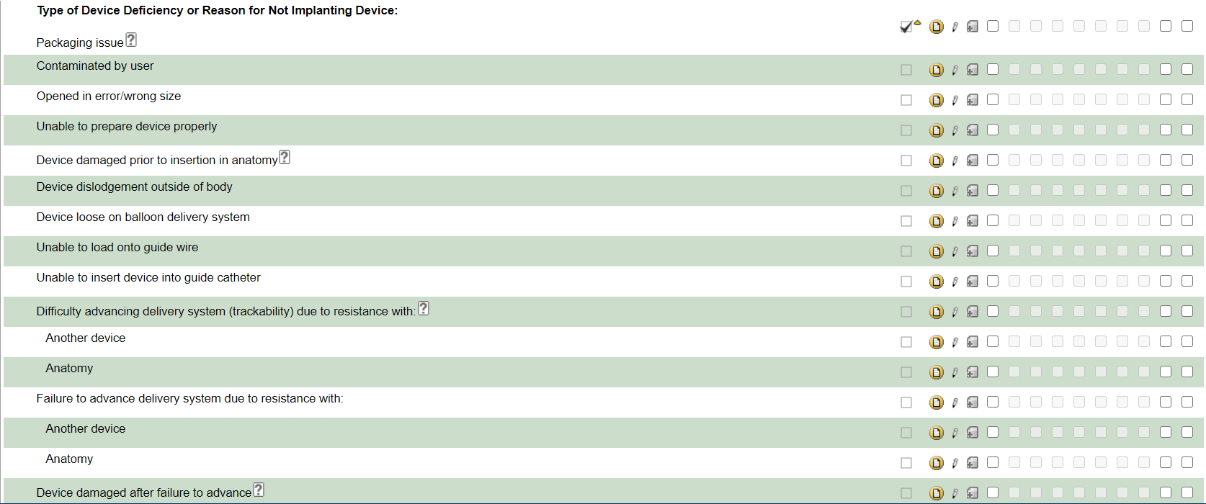





Figure DM Form fields that will be going to RECON

1. Subject Details Metadata from Demographics and Physical Measurement Form:









Figure Subject Details Fields that will be going to RECON

* The provided data in the above mentioned fields in those forms are eligible only to go to the RECON system.
* The data received on the RECON system updates on everyday 5.30pm IST / 12 pm GMT.
* The data that is created on a particular day, will be reflected on the very next day after that specified time above.